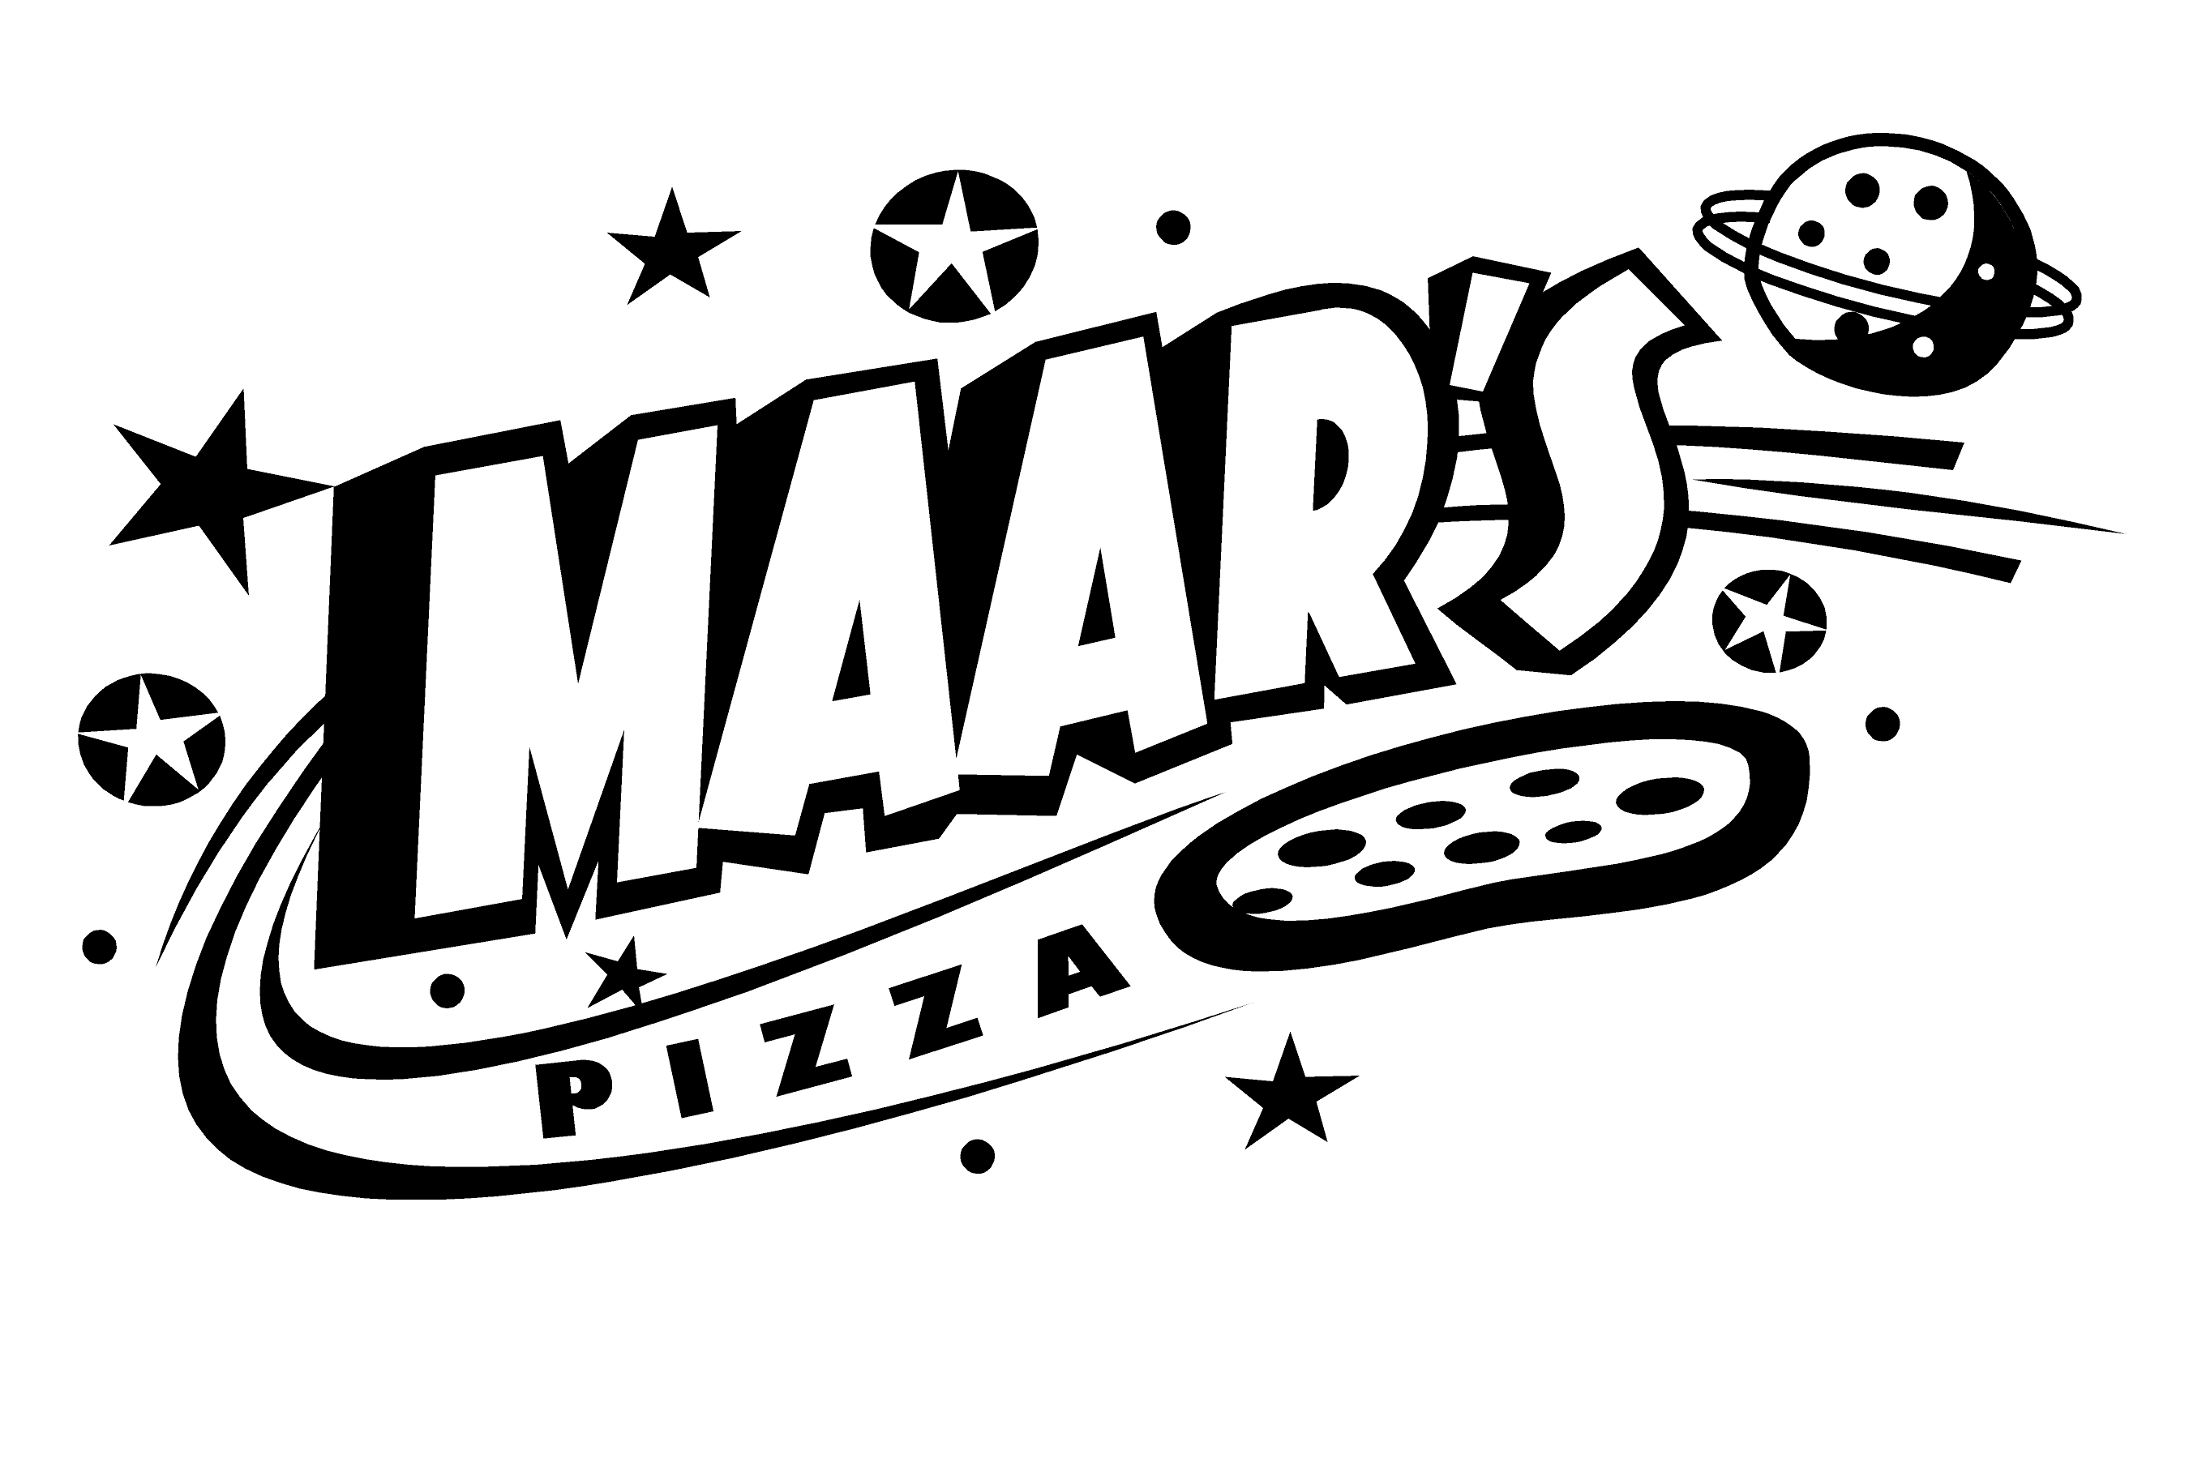 | MAAR’s PIZZA & MORE

Applicant Information
Full Name: |  |  |  | Date:
 | Last | First | M.I.
Address:
 | Street Address |  |  |  |  | Apartment/Unit #
 | City |  | State |  |  | ZIP Code

Phone: |  | Email

Social Security No: | (If Hired, need copy)

Position Applied for:

Have you ever been convicted of a criminal offense (felony or misdemeanor)? | YES | NO

If yes, explain:

Availability
Availability:
Qualifications:
Restaurant experience:

Previous Employment
Company: |  | Phone:

Job Title: |  | Starting Salary: | $ | Ending Salary: | $

Responsibilities:

From: |  | To: |  | Reason for Leaving:

May we contact your previous supervisor for a reference? |  |  | YES | NO

Disclaimer and Signature
MAAR’s Pizza & More is an equal opportunity employer.
I certify that my answers are true and complete to the best of my knowledge.
If this application leads to employment, I understand that false or misleading information in my application or interview may result in my release.
Signature: |  | Date:

