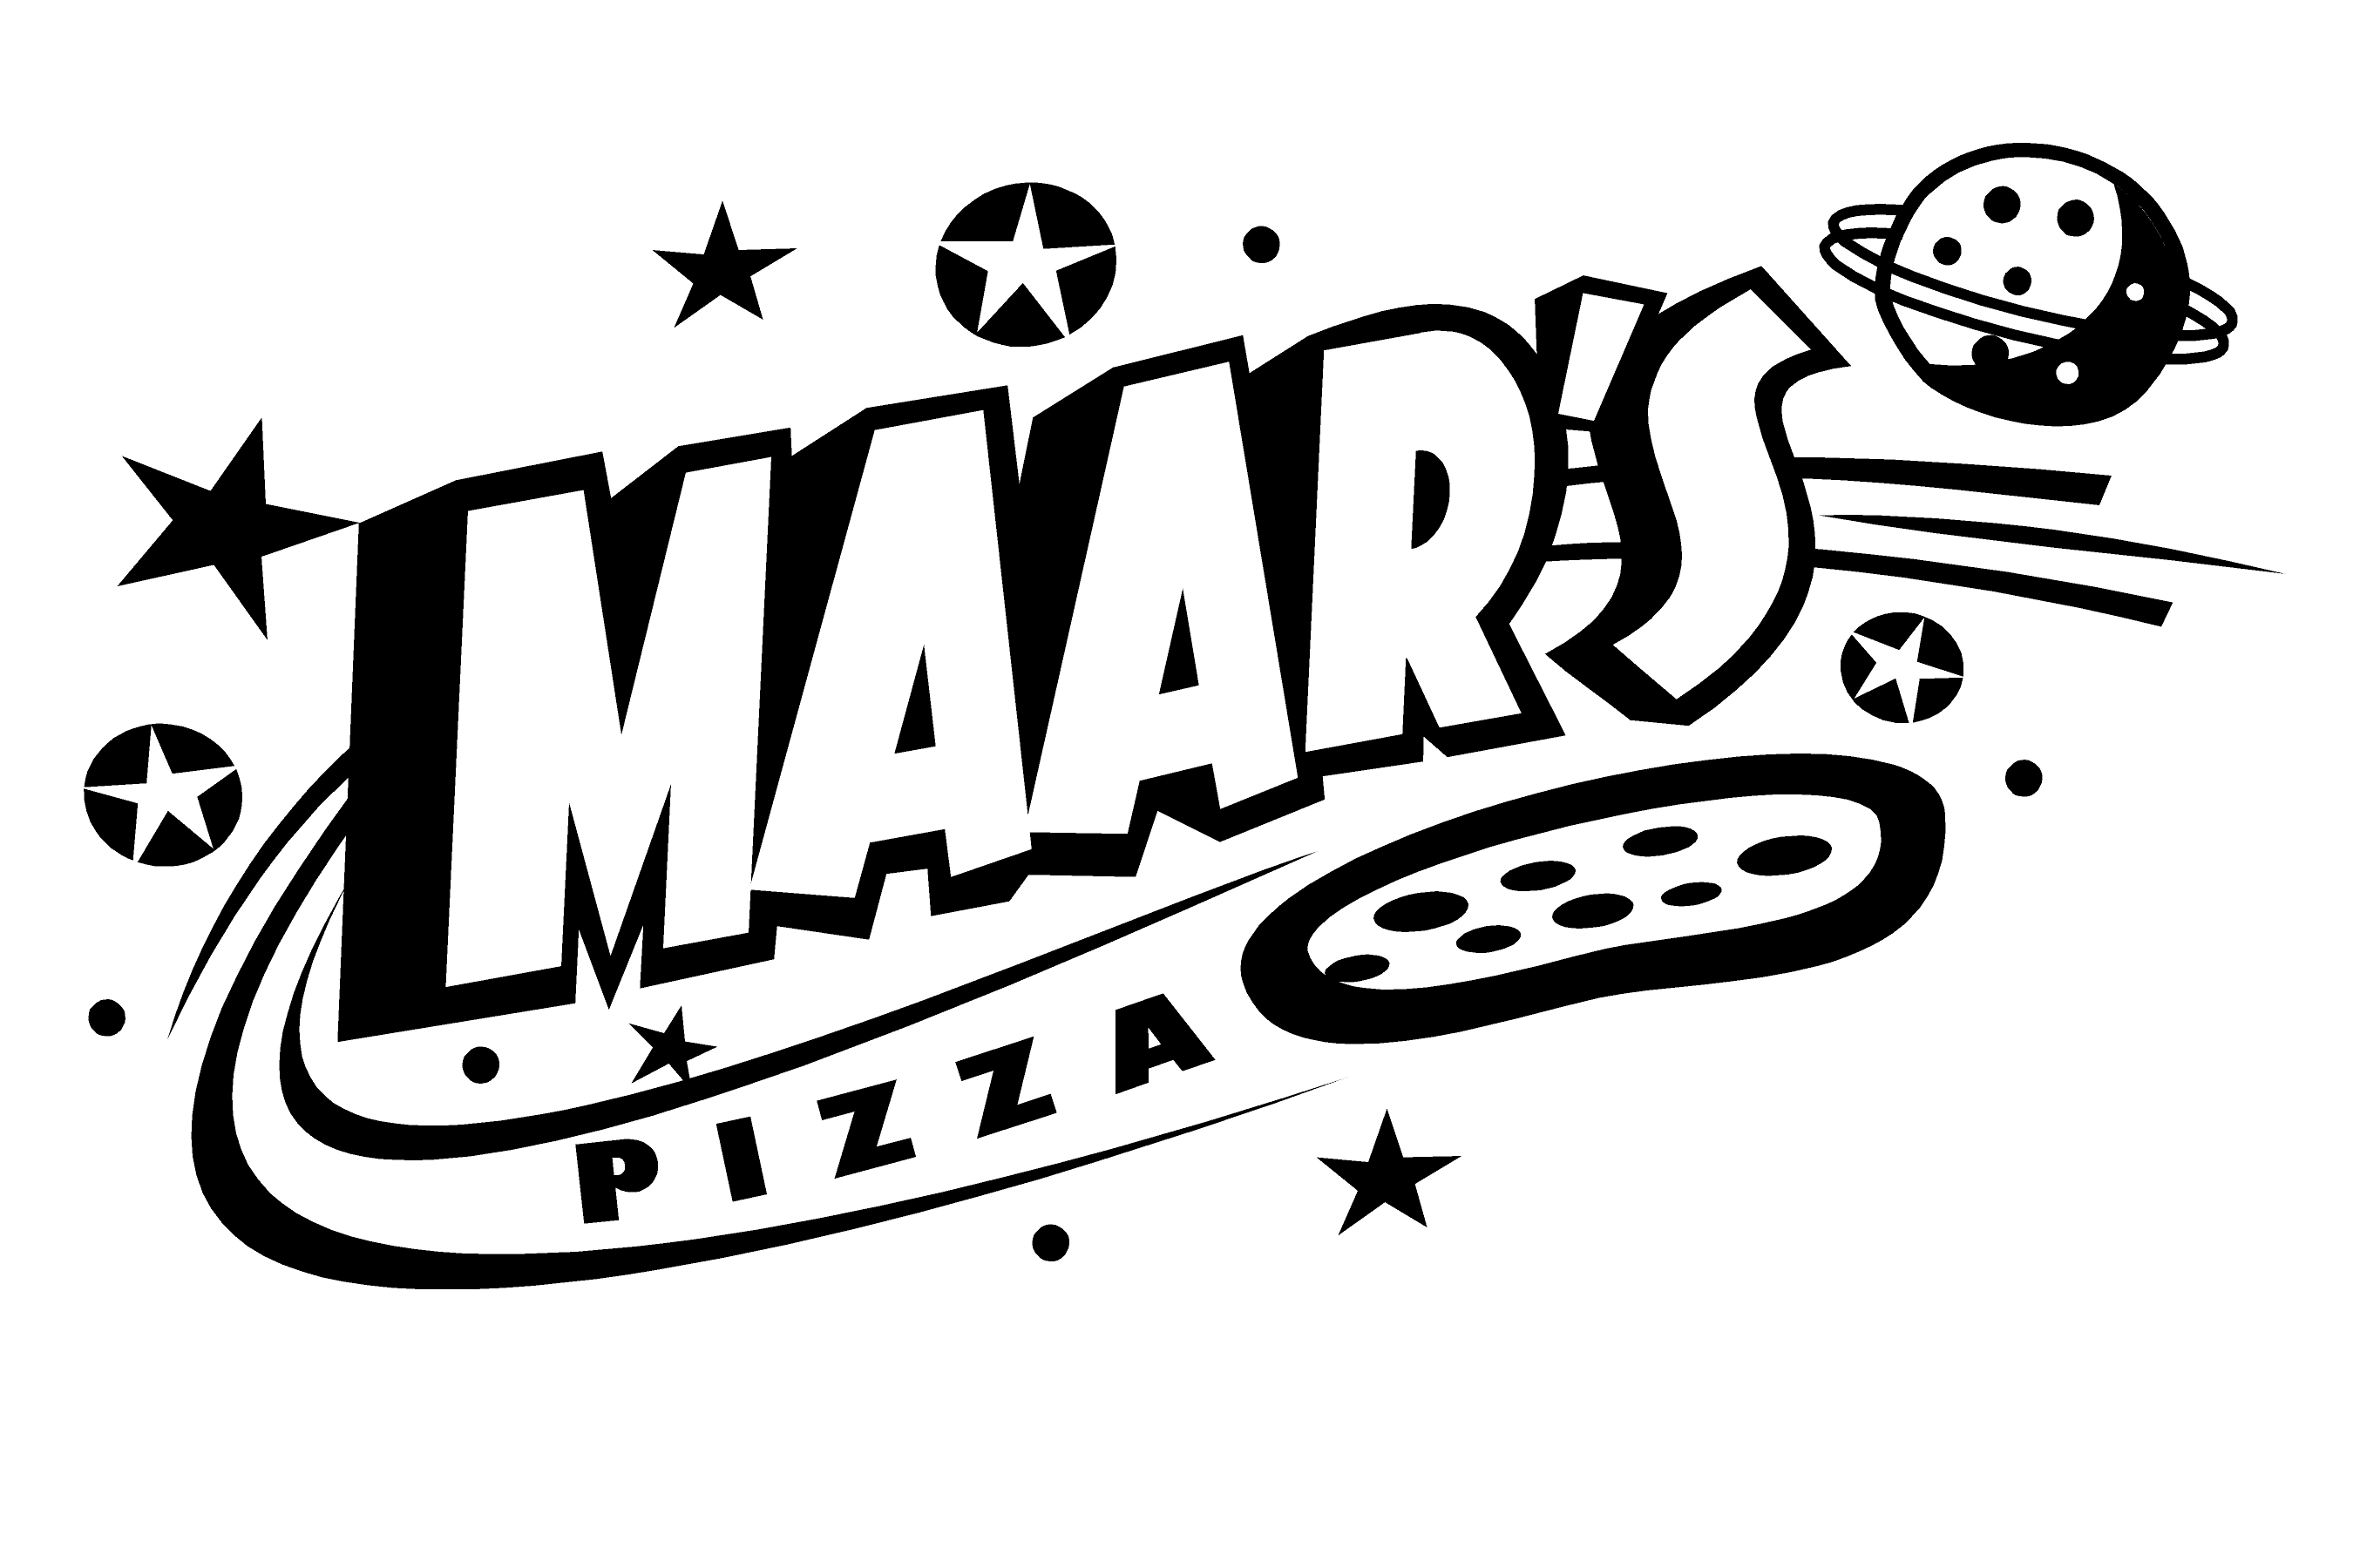 | MAAR’s PIZZA & MORE

Employment Application

Applicant Information
Full Name: |  |  |  | Date:
 | Last | First | M.I.
Address:
 | Street Address |  |  |  |  | Apartment/Unit #
 | City |  | State |  |  | ZIP Code

Phone: |  | Email

Date Available: |  | Social Security No.: |  | Desired Salary: | $

Position Applied for:

Are you a citizen of the United States? | YES | NO | If no, are you authorized to work in the U.S.? |  |  | YES | NO
Are you over 16 years old? | YES | NO | If applying for driver, are you over 25? |  |  | YES | NO
If applying for server, are you over 18? | YES | NO | If hired, are you willing to submit to &  pass a controlled substance test?? |  |  | YES | NO
Are you currently enrolled in school? | YES | NO
Have you ever been convicted of a felony? | YES | NO

If yes, explain:

Education

High School:

From: |  | To: |  | Did you graduate? | YES | NO

College:

From: |  | To: |  | Did you graduate? | YES | NO | Degree:

Availability
Availability:
Any days you cannot work?
Explain:
Qualifications:
Restaurant experience:

Previous Employment
Company: |  | Phone:
Address: |  | Supervisor:

Job Title: |  | Starting Salary: | $ | Ending Salary: | $

Responsibilities:

From: |  | To: |  | Reason for Leaving:

May we contact your previous supervisor for a reference? | YES | NO

Company: |  | Phone:
Address: |  | Supervisor:

Job Title: |  | Starting Salary: | $ | Ending Salary: | $

Responsibilities:

From: |  | To: |  | Reason for Leaving:

May we contact your previous supervisor for a reference? | YES | NO

Disclaimer and Signature
MAAR’s Pizza & More is an equal opportunity employer.
I certify that my answers are true and complete to the best of my knowledge.
If this application leads to employment, I understand that false or misleading information in my application or interview may result in my release.
Print Name: |  | Date:
Signature:

